**Gen-Z Career Insights: Findings from MySQL Data Analysis**

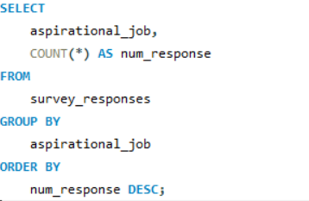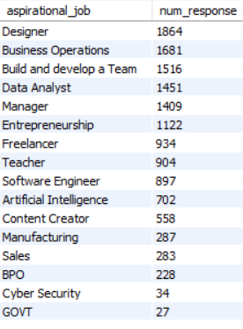1. What industries are Gen-Z most interested in pursuing careers in?  
**Insights:**

High interest in Creative, Business, and Tech Careers → Indicates strong demand for roles in design, business operations, team leadership, data analysis, and software development.

Significant interest in Entrepreneurship and Freelancing → Shows Gen-Z’s desire for independence, flexibility, and control over their careers.

Growing focus on Data Analytics and AI → Suggests that Gen-Z sees technology and data skills as future-proof and high-potential fields.

Low interest in Traditional Sectors like Manufacturing, Sales, BPO, Government → Could reflect lack of appeal, awareness, or perceived growth opportunities in these fields.

Content Creation remains popular → Points to Gen-Z’s comfort with digital platforms, personal branding, and creative self-expression.

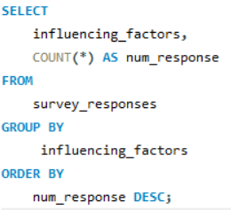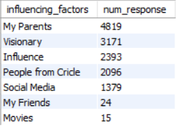2. What are the top factors influencing Gen-Z’s career choices?

**Insights:**

Parents have the strongest influence → Shows family plays a crucial role in guiding Gen-Z’s career paths and decisions.

Visionary thinking is significant → Many Gen-Z individuals are driven by personal goals, ambition, and long-term visions for their future.

Wider social influence matters → Influencers, mentors, and people in their circles also shape career aspirations, highlighting the role of networks and community.

Social Media impacts choices → Digital platforms are important sources of inspiration and information for career decisions among Gen-Z.

Friends and media like movies have minimal influence → Suggests that close peers and entertainment media play a smaller role in serious career choices.

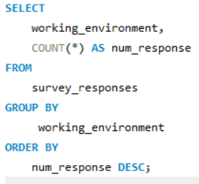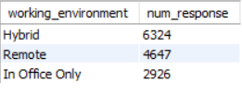  
3. What is the desired work environment for Gen-Z?

**Insights:**

Hybrid work is the top preference → Most Gen-Z prefer a flexible work model that balances office and remote work.

Remote work is highly favored → A large portion of Gen-Z values location freedom and digital-first environments.

In-office work is least preferred → Traditional office setups are becoming less attractive to Gen-Z, possibly due to a desire for better work-life balance.

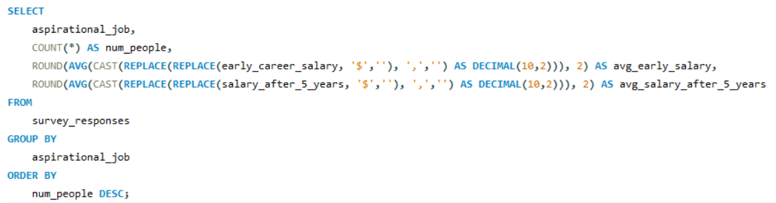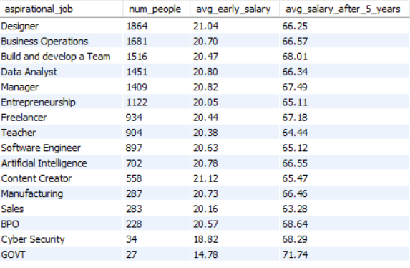4. How do financial goals, such as salary and benefits, impact career aspirations among Gen-Z?

**Insights:**

Overall modest early salaries, but strong growth expectations → Most Gen-Z aspire to salaries around ₹20–21k early in their careers, expecting to triple or more in five years.

Government jobs show the lowest early salary but highest future growth → Despite low starting pay (₹14.78k), government careers promise the highest jump to ₹71.74k, indicating long-term security appeal.

Creative and tech roles attract higher early pay → Roles like Designer and Content Creator show higher starting salaries (above ₹21k), suggesting higher perceived market value for creative skills.

Leadership and management roles forecast stronger growth → “Build and develop a Team,” BPO, and Manager roles have higher 5-year salary projections (around ₹68–69k), signalling leadership roles as lucrative long-term goals.

Fields like Teaching and Sales offer slower salary growth → These careers start with modest salaries around ₹20k and rise only to about ₹63–65k after 5 years, which may reduce their attractiveness for Gen-Z seeking faster financial progress.

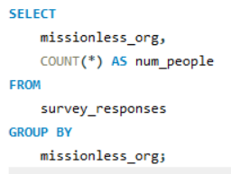  
5. What role do personal values and social impact play in career choices for Gen-Z?

Personal values and social impact influence Gen-Z’s careers, but not for everyone →

Around 28% (3,842 people) say social impact does matter in their career choices.

About 72% (10,055 people) say social impact does not play a significant role in their decisions.

Insight: While a strong segment of Gen-Z values working for organizations with a social mission, the majority still prioritize other factors—possibly salary, job security, or growth opportunities—over social impact.